**MongoDB (ASSIGNMENT-2)**

1.Creating collection from Database University.

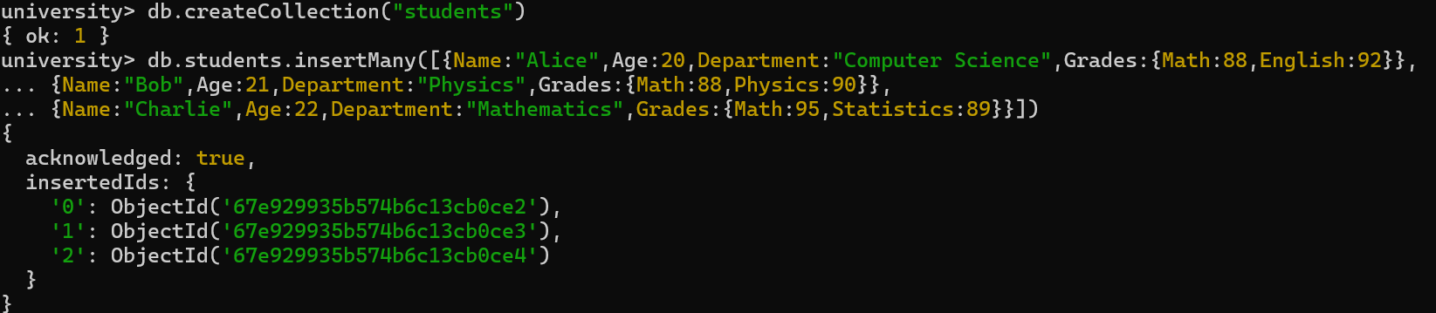

2. Write a query to display all students who are in the Computer Science department.

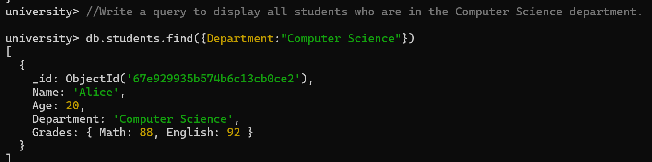

3. Write a query to update the grades of a student named Alice by adding a new subject programming with a grade of 93.

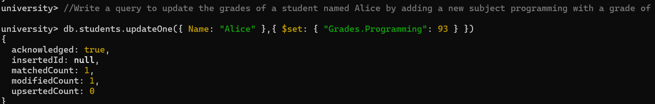

4. Write a query to increment the age of all students by 1?

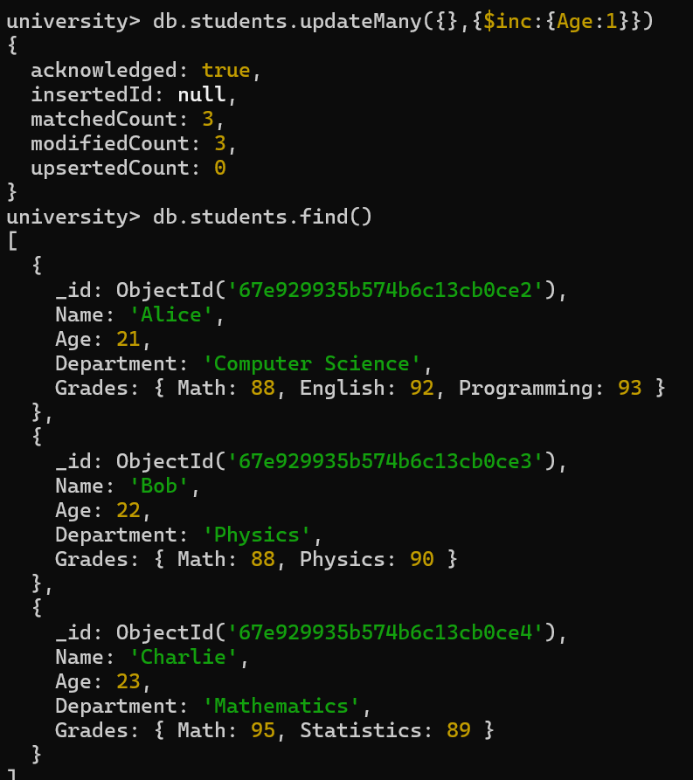

5. Write a query to delete all students who are 23 years old?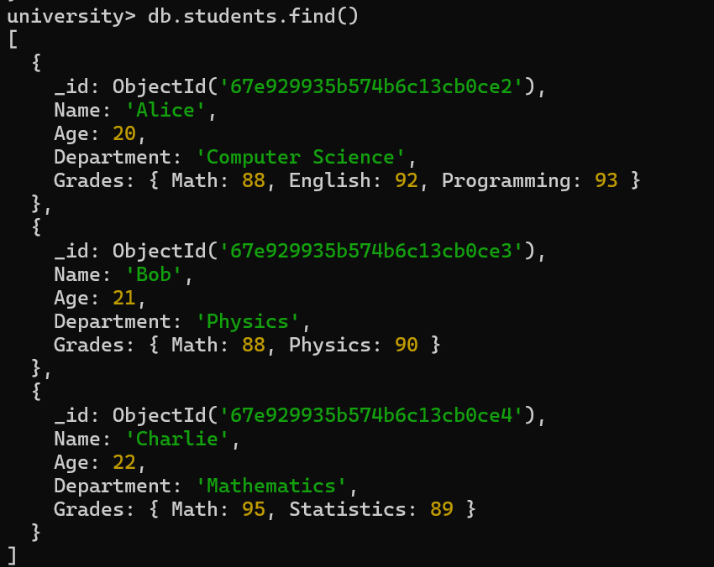

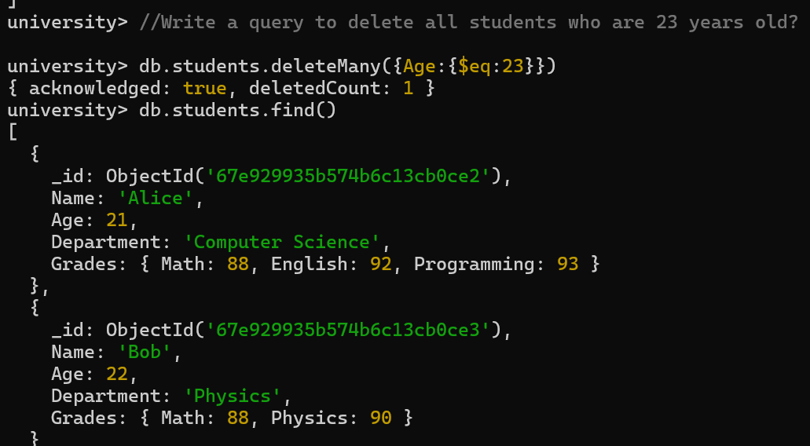

6. Write a query to create an index on the name field of the students collection?

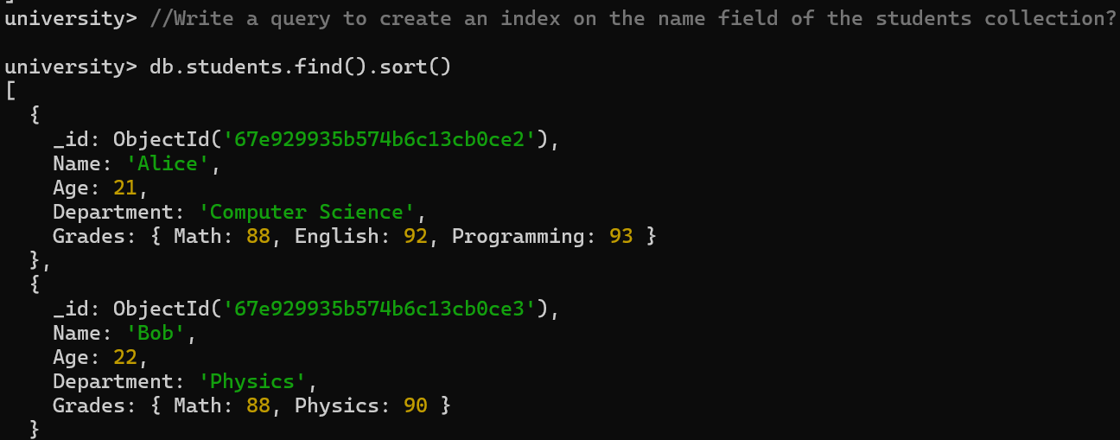

7. Write an aggregation query to group students by their department and calculate the average age in each department?



8. Write a query to find all students who have scored more than 90 in any subject?

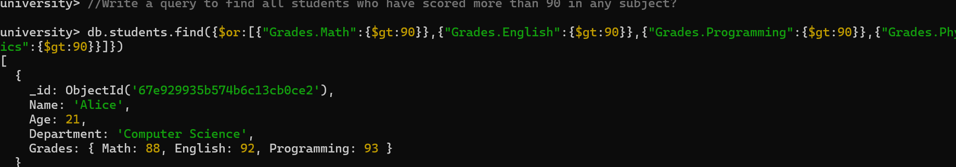

9. Write a query to add a new field graduated set to false for all students who are in the Mathematics department?

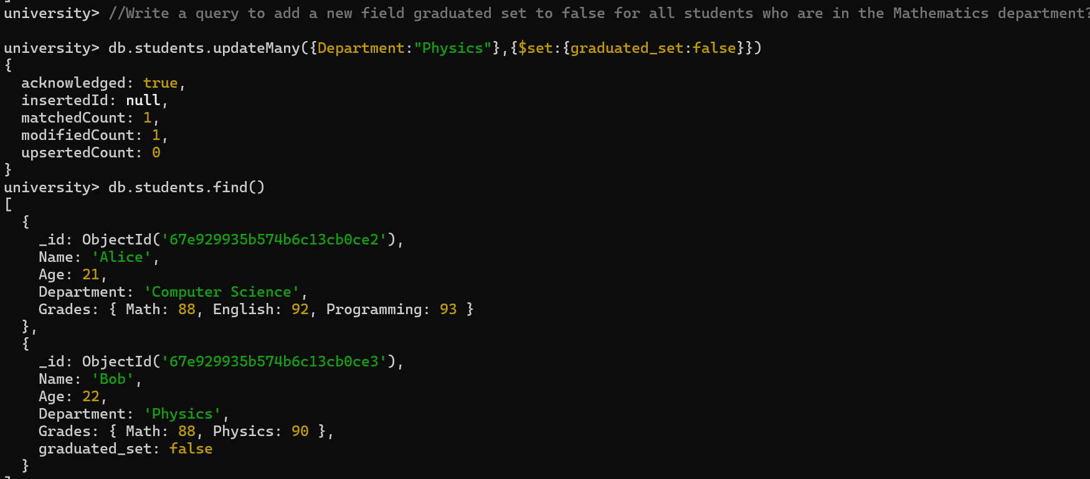

10. How can you retrieve only the name and department fields for all students, excluding the _id field?

